**Final Project Report**

**ON**

**Machine Translation of Noisy Text (MTNT)**

**Stevens Institute of Technology**



Project Guide:

Professor Abdul Rafae Khan

Submitted by:

Janmejay Mohanty

[jmohanty@stevens.edu](mailto:jmohanty@stevens.edu)

Course Name:

CS 541-A Artificial Intelligence

**Abstract**

In most modern Machine Translation (MT) systems, noisy or non-standard input text can result in devastating mistranslations, and there has been a growing research interest in developing noise-resistant MT systems. However, there are currently no publicly available parallel corpora of naturally occurring noisy inputs and translations, therefore past research has had to rely on synthetically constructed datasets for evaluation. The author presents a benchmark dataset for Machine Translation of Noisy Text (MTNT) in this study, which includes noisy Reddit comments and professionally supplied translations. On the huge number of sentences per language pair, we commissioned translations of English comments into French and Japanese, as well as French and Japanese comments into English. We look at the many types of noise in this dataset both qualitatively and quantitatively.

Some sample analysed data stats given as below:

1. Counted the number of profanities using the following below command:

cat MTNT/test/test.en-fr.en | python3 analysis/count_keywords.py resources/profanities.en

Result = 38

1. Counted the number of emojis (after importing the emojis module in python) using the following below command:

cat MTNT/test/test.en-fr.en | python3 analysis/count_emojis.py

Result = 46

1. Checking the ratio between US/UK spelling (for ise/ize which is a good indicator) using the following below command:

cat MTNT/test/test.en-fr.en | python3 analysis/uk_us_ratio.py

Result = 35.7% and 64.3%

Git-hub Link:

<https://github.com/Janmejay1998/MTNT_AI>

**Introduction**

There are many random reddit messages and text data that contains large noisy data and also contains slangs.

#nlproc is actualy f*ing hARD tbh

The above reddit text is an example of containing slangs and noisy data.

Sometimes it also contains emojis. Although the machine translation algorithm has been improved quite in the past few years due to many introductions of Neural Network and Machine Learning algorithms. But still there are many human errors in social media text which are still not being able to get resolved by these new coming Neural network and machine learning algorithms.

So right now, our current goal is to perform test on standard translation models and language models on our data for understanding their failure cases and to provide better and optimized approaches for the future task.

We faced many problems such as many deprecated lines of code, outdated and inappropriate libraries path and files directory which we had fixed and resolved it but still there are some error and problems remains which we had to fix it but unable to do so.

**Data**

For each different language, we are selecting a set of groups (“subreddits”) that we know contains many comments in that language such as English: Since a huge majority of the discussions on Reddit took place in the medium of English, so we don’t restrict our collection to any community in particular.

English: As huge majority of the discussions on Reddit are conducted in English, we are not restricting our collection to any specific community.

French: The total of the French side of the parallel training data which is provided for the English-French WMT 2015 translation procedure. This amount is to be approximately 40.86 million sentences.

Japanese: We had collected three small/medium sized MT datasets: KFTT (Neubig, 2011), JESC (Pryzant et al.) and TED talks (Cettolo et al., 2012), amounting to be approximately ≈ 4.19 million sentences.

The data files for MTNT can be found in this link: <https://github.com/Janmejay1998/MTNT_AI/tree/main/mtnt-master/config>

Most of the data we are dealing with are from Reddit based data.

**Tools & Technologies**

**Software Requirements:**

Currently running on Windows Operating System:

Version = Windows 10 (Latest)

Using both version of python 2.7 and 3.6

To run this project code, you are required the following python modules to be installed:

1. kenlm
2. langid
3. numpy
4. pickle
5. praw
6. sentencepiece >=0.1.6 (Version)
7. yaml

Also, you are required to use Ubuntu Terminal as it contains both shell codes and programs:

Ubuntu Version = 18.04 LTS

Using VirtualBox 6.1 tool to create and setup Ubuntu Terminal version 18.04 LTS for running the project.

**Hardware Requirements:**

Using personal CPU and GPU which are:

1. CPU = AMD RYZEN 7 5800H
2. GPU = NVIDIA GEFORCE RTX 3060

**Data**

For pre-processing the data, you are required to perform following things:

1. Moses: For tokenization, clean-up, etc... (<https://github.com/moses-smt/mosesdecoder>)
2. Sentencepiece: For subwords. (<https://github.com/google/sentencepiece>)
3. KenLM: For n-gram language modelling. (<https://kheafield.com/code/kenlm/>)

If you want to work on Japanese language data you can install Kytea (for word segmentation)

Reference link: <http://www.phontron.com/kytea/>

For preparing and downloading the data use the given below commands:

# Monolingual en data from WMT17

bash scripts/download_en.sh config/data.en.config

bash scripts/prepare_model config/data.en.config

# Monolingual fr data from WMT15

bash scripts/download_fr.sh config/data.fr.config

bash scripts/prepare_model config/data.fr.config

# Prepare en<->fr parallel data

bash scripts/prepare-en-fr.sh config/data.fr.config path/to/moses/scripts

# Download and prepare the en<->ja monolingual and parallel data

bash scripts/download_ja.sh config/data.ja.config path/to/moses/scripts

# New MTNT File uploaded here

<https://github.com/Janmejay1998/MTNT_AI/tree/main/mtnt-master/MTNT>

# Split the tsv files

bash MTNT/split_tsv.sh

After completing the above command execution, for Running the Scraper you can go through the below description and some commands are mentioned below:

For editing the config/{en,fr,ja}_reddit.yaml to include the appropriate credentials for your own bot. You can modify some of the parameters and settings such as subreddits, etc...

For this you have to run this command which I have mention below:

bash scripts/start_scraper.sh [config_file]

**Note:** When you are running this scraper, please go through the Reddit API terms on their official website. (<https://www.reddit.com/wiki/api>)

After completing all these procedures, for analysis the data, please use the following given below commands for project execution:

# Count the number of profanities (should return 38)

cat MTNT/test/test.en-fr.en | python3 analysis/count_keywords.py resources/profanities.en

# Count the number of emojis (should return 46)

cat MTNT/test/test.en-fr.en | python3 analysis/count_emojis.py

# Check the ration US/UK spelling (for ise/ize which is a good indicator) (should return 35.7% 64.3%)

cat MTNT/test/test.en-fr.en | python3 analysis/uk_us_ratio.py

# Count the number of informal pronouns (in japanese) (should return 35)

kytea -model /path/to/kytea/data/model.bin -out tok MTNT/test/test.ja-en.ja | python3 analysis/count_keywords.py resources/informal_pronouns.ja

**Results:**

This shows the output results of the files being generated for MTNT.

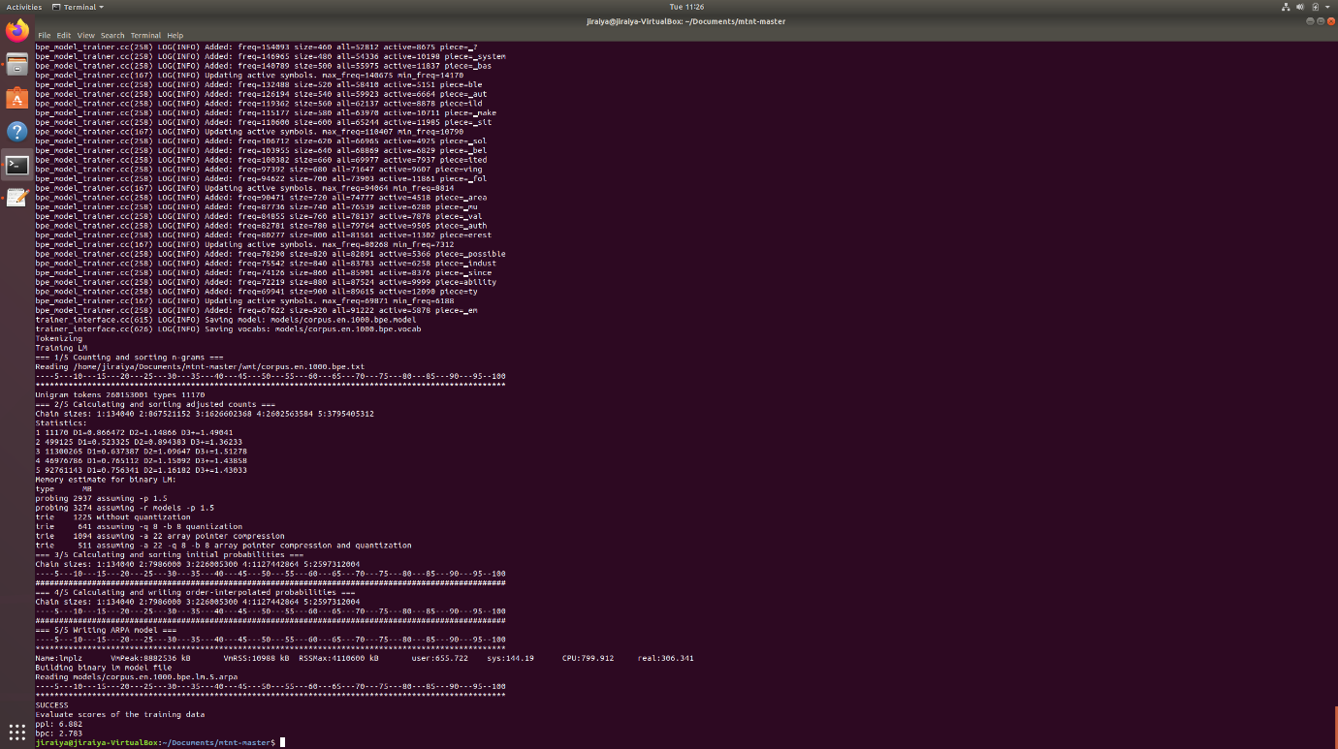

Evaluated scores of the training data are as follows:

ppl: 6.882

bpe: 2.783

The given below shows the accuracy of the processed and examined data.

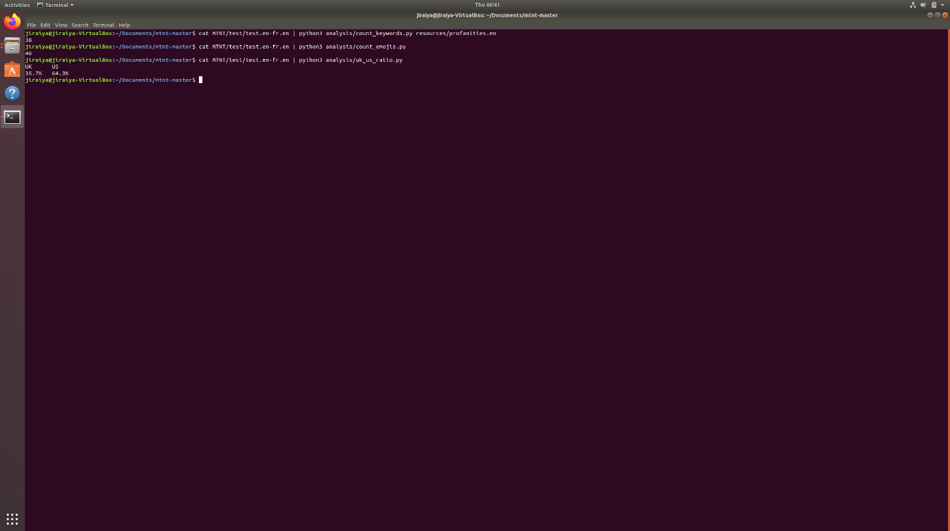

**Problems and Issues:**

Due to the outdated project version. Some libraries had been deprecated and creating errors.

For example:

I had attached the screen shots right below so you can have a look.

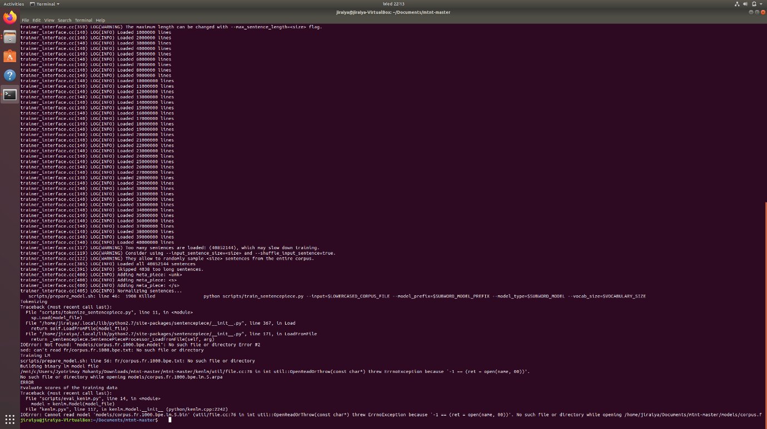

I had done several times the execution and tries to resolve it by changing Python version, but still this issue hadn’t resolved. Maybe there are some new libraries got released in place of these older version libraries which can run this project code properly without any issues.

We had successfully fixed the tokenize_sentencepiece.py files error and kenlm model related issues. Right now, we had fixed its performance and it is evaluating properly and giving optimization accuracy rate for it.

For that we need to run it on pure ubuntu terminal environment and we had successfully made and setup it for this project.

**Conclusion**

We demonstrate a new dataset to test MT models' resistance to the many types of noise found in natural language on the Internet. For two language pairs, English French and English, we submit parallel training and test data in both directions.

For two language pairs,

Japanese, as well as statistics in those languages that are monolingual three distinct languages. We show that this dataset has more noise than existing MT test sets and that it is more difficult to interpret.

Models who have been educated on conventional models have a hurdle to models trained on standard MT corpora is a collection of MT corpora. Furthermore, we show that these

A simple domain adaptation technique will not be enough to solve the obstacles. This is our intention to contribution for the creation of a standard benchmark for resilience in the noise in MT and encourage research on customized models, datasets, and evaluating the metrics for this exact issue or problems.